ANIMATRONICS FACE:

PROFFeSSOR NEDUNGADI

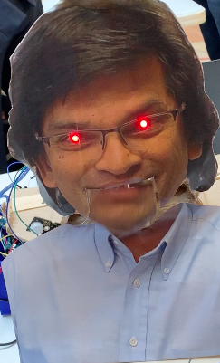

Ryan Thompson

Dept. of Mechanical Engineering

San Antonio, TX, USA 78249

[cue197@my.utsa.edu](mailto:cue197@my.utsa.edu)

Sean Nolen

Dept. of Mechanical Engineering

San Antonio, TX, USA 78249

[lym914@my.utsa.edu](mailto:lym914@my.utsa.edu)

Johnathan Ledwig

Dept. of Mechanical Engineering

San Antonio, TX, USA 78249

[syw698@my.utsa.edu](mailto:syw698@my.utsa.edu)

Submitted as part of project for ME4543 Mechatronics, Fall 2018

**TABLE OF CONTENTS**

|  |  |
| --- | --- |
| Abstract | 1 |
| Literature Review | 2 |
| Supporting Structure | 4 |
| Joints and Motors | 6 |
| Sensors | 10 |
| Programming | 11 |
| Lesson learnt and suggestions | 13 |
| Personnel and Bill of Materials | 13 |
| References | 15 |
| Appendix A: Code snippets | 16 |
| Appendix: Arduino wiring | 21 |

**ABSTRACT**

Over the Course of the semester each mechatronics team created an animatronic face to meet the requirements presented by the professor. The key specifications for the project include, two motions, moving mouth and audio. Lab 2 Team 5 created an animatronic face based off of Professor Ashok Nedungadi, which includes an audio of his voice, head tilt, mouth movement and led eyes. Each movement is made possible through the use of servo motors that are triggered by different sensors and driven by an Arduino board. The three sensors that were used are an inferred sensor to trigger the mouth movement, an ultra-sonic sensor to trigger the LED eyes and a captive touch sensor to trigger the head movement. A button was used to trigger the recorded audio.

**Section 1: Literature review**

Animatronics have evolved rapidly enough with a vast amount of resources that talking robots can be made from common household items. Items including ping pong balls (eyes), plywood (structure), and simple wires for the functions. The animatronic design analyzed was the talking robot head. The face consists of eye balls, wires, sensors and made from ½ inch plywood. The method used for creating this robot was making a cardboard head and jaw at first to make room for all the servos. After everything was cut out and test-fitted with servos, the cardboard was replaced with plywood and a couple coats of polyurethane varnish were put on the wooden parts (Figure 1). For electrical components of the robot, a servo controller and RAPU was used as the central source. The servo controller takes serial signals from the RAPU and translates them into movements (Figure 2). The RAPU takes written programs and stores both the movement commands and audio. It can control up to 64 devices including MiniSSC-compatible servos, Pololu Maestro servos/motors/relays, LynxMotion SSC32 servos/relays, K108A relays, and BoC DMX servos. Or, the RAPU can control up to 128 DMX devices and compatible hardware [6]. The power supplies and computer speakers are housed in a black wooden box beneath the head. A fan was also included in the box to dissipate heat buildup (Figure 1) [5].

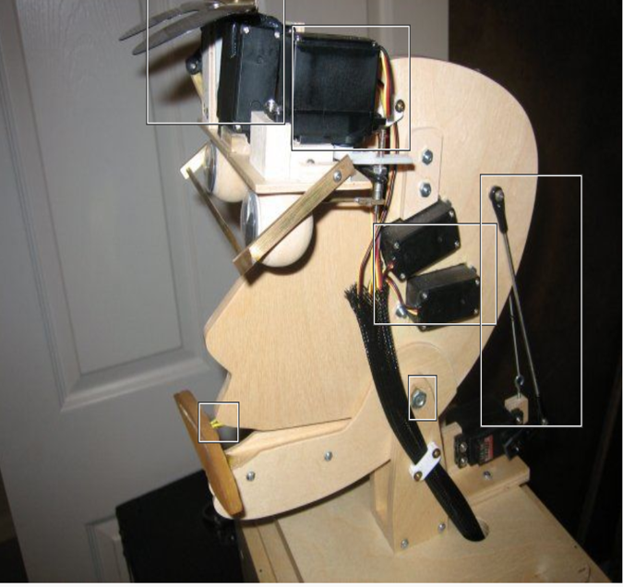

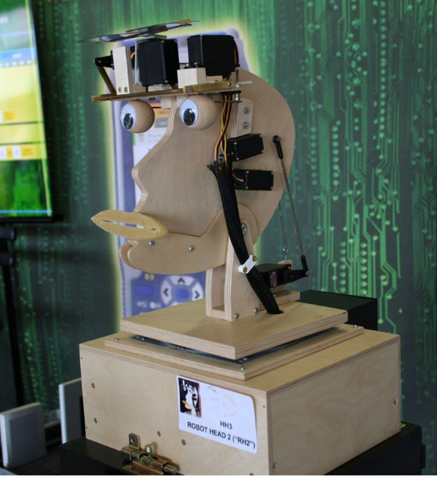

*Figure 1: Robot head front view* *Figure 2: Robot head side view*

Advancements in animatronics has been on a rise. The new technology has gone as far developing a sex bot that will interact with its customers. Since over 60% of human communication is nonverbal, facial expressions and gestures are common was of communicating. Roman is a humanoid robot that is behavior based emotional control architecture. This means that this is based on 3 main parts which interact with each other: emotions, drives and actions. It is used for assistance and education research. The communication feedback is made possible with sensors and actuators. All of this is made possible by mechanics, computer architecture and sensor system. The majority of these components are made up of an Embedded PC, Soundcard, IEEE 1394, Cameras, Microphones, Internal system, 6 stepper motors (AM1524), 4 DC micromotors (2224U), 1 S-50XX, and 10 S-4251. ROMAN can be seen in Figure 3. This information came from reference [1].

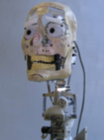

*Figure 3 Humanoid Robot ROMAN*

Animatronic faces and other body parts have been used in several different industries and can be built using endless designs and mechanism. Figure 4 below shows an example of a unique animatronic face. While many different materials can be used for the structure of an animatronic face, this design utilizes cardboard for the facial structure and the neck. However, the cardboard animatronic faces utilize external speakers for sound, this can be avoided by purchasing smaller speakers to build into the structure. The ability to speak is a critical component of most robots since this is the main method of interaction between humans. Therefor the design of the animatronic face mouth can become a critical aspect of the design. The design shown below in figure 4, shows a solid moving mouth, however an alternative that can move more fluidly is to use a LED board [1]. However, if the mechanics of a physical moving mouth RE meticulously and accurately designed, then the moving mouth will look more realistic.

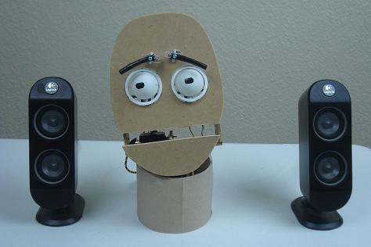

*Figure 4: Cardboard animatronic face*

Although this design seems simples, many different parts were required to construct the face. The material list shows that the motion for the mouth was generated using a servo motor, and a [PIC 18F452](http://www.pyroelectro.com/parts/PIC_18F452/), which will act as the brains, telling the servo motor when and how to move. There are many reasons servo motors are so common in electronic projects. A servo motor is so effective because it has a feedback mechanism [4]. “The feedback loop allows the motor input current to be adjusted automatically to properly position the servo shaft when the sensors tell the controller that it’s time to move the shaft or that the motor is not performing as it should [4].” In addition to servo motors there are also many advantages to using a PIC. According to [Margaret Rouse](https://www.techtarget.com/contributor/Margaret-Rouse), key features of a PIC microcontroller “include wide availability, low cost, ease of reprogramming with built-in electrically erasable programmable read-only memory”[3]. The important aspect of a PIC is the low cost per unit. In this design it is also important to note the simple mechanics of the eyebrows. Dynamic movement on a face can become difficult however the motions can be simplified by making a lever with one point of rotation. This can be seen in the eyebrows of the cardboard animatronic face in figure 4, the eyebrows were modeled as simple levers. In summary, there are many different ways to approach the design of a mechatronic face, however a key point will be approximating and simplifying the dynamic movements of a face.

nic faces and other body parts have been used in several different industries and can be

built using endless designs and mechanism. Figure BLAH BAH below shows an example of an

animatronic face. The design utilizes cardboard for the facial structure and the neck, as well as

external speakers for sound. Any robot will likely need the ability to speak since this is the main

method of interaction between humans. Therefor the design of the mouth can become a critical

aspect of the design. The design shown below in figure BLAH, shows a solid moving mouth,

however and alternative that can move more fluidly is to use a LED board (1).

Figure BLAH BLAH

Although this design seems simples, many different parts were required to construct the face.

The material list shows that the motion for the mouth will be generated using a servo motor, and

a PIC 18F452 will act as the brains, telling the servo motor when and how to move. There are

many reasons servo motors are so common in electronic projects. A servo motor is so effective

because it has a feedback mechanism (3). “The feedback loop allows the motor input current to

be adjusted automatically to properly position the servo shaft when the sensors tell the controller

that it’s time to move the shaft or that the motor is not performing as it should (3).” In addition to

servo motors there are also many advantages to using a PIC. According to Margaret Rouse, key

features of a PIC microcontroller “include wide availability, low cost, ease of reprogramming

with built-in electrically erasable programmable read-only memory”(2). The important aspect of

a PIC is the low cost per unit.

**Section 2: Brainstorming (initial planning)**

Team 5s animatronic face will have two movements and three methods of interaction with the audience. Each of the two motors will be initiated using a servo motors, one of the servo motors will tilt the head back while the other servo motor will move the mouth. The three methods of interaction with the audience will be made possible through the use of different sensors including, inferred sensor to trigger the servomotor for the mouth, push button touch sensor to trigger the servo for the head tilt, and a proximity sensor to turn on red LED’s that will act as eyes. Each sensor and motor will be driven by an Arduino board, which will be receiving power from a portable power supply that has a USB output and provides sufficient voltage and amperage to power the system.

The chassis for the animatronic figure will be made out of cardboard and any additional required support material will be provide by using wooden paint sticks. The face for this system will be simply a color print out of the professor’s face and will be mounted directly to the chassis using hot glue.

In addition to the movements from the servo motors the animatronic face will also be designed to produce audio of the professor’s voice. The audio will be of predetermined and record phrases that are unique to the specified professor. The phrases that will be recorded and played through the animatronic face include, “There is absolutely no black magic in engineering. In engineering always remember safety first, safety safety safety! Engineers do not believe in lab manuals; lab manuals are for technicians.”

**Section 3: Supporting structure**

The supporting structure of the animatronic face is certainly a critical aspect of a successful project. For this project it is important that the structure and frame be light weight since the servo motors that will be used do not have the necessary torque to move a heavy structure. Another characteristic that played a roll deciding on a supporting structure, is the flexibility and feasibility of use, meaning the team wanted a material that was easy to work with and make adjustments. The third criteria that was used when deciding on a supporting structure was cost, it was important to the team that the supporting structure be as cheap as possible.

After the criteria for the supporting structure was determined, selecting a material was rather simple. Cardboard was selected as the main component of the frame since the cardboard was free, light, and can provide the support required for the system. The only downside to using cardboard as the supporting material, is the impact of moisture and may become brittle after multiple bends to the same area. However, this does not effect this project since it will only be used indoors and high bend areas can be reinforced. The structure support will be reinforced by wooden paint sticks. Figure 5 below shows the material that was used for the structure and support of the face which was pulled from a 3d printer shipping container and gathered from Lowes.

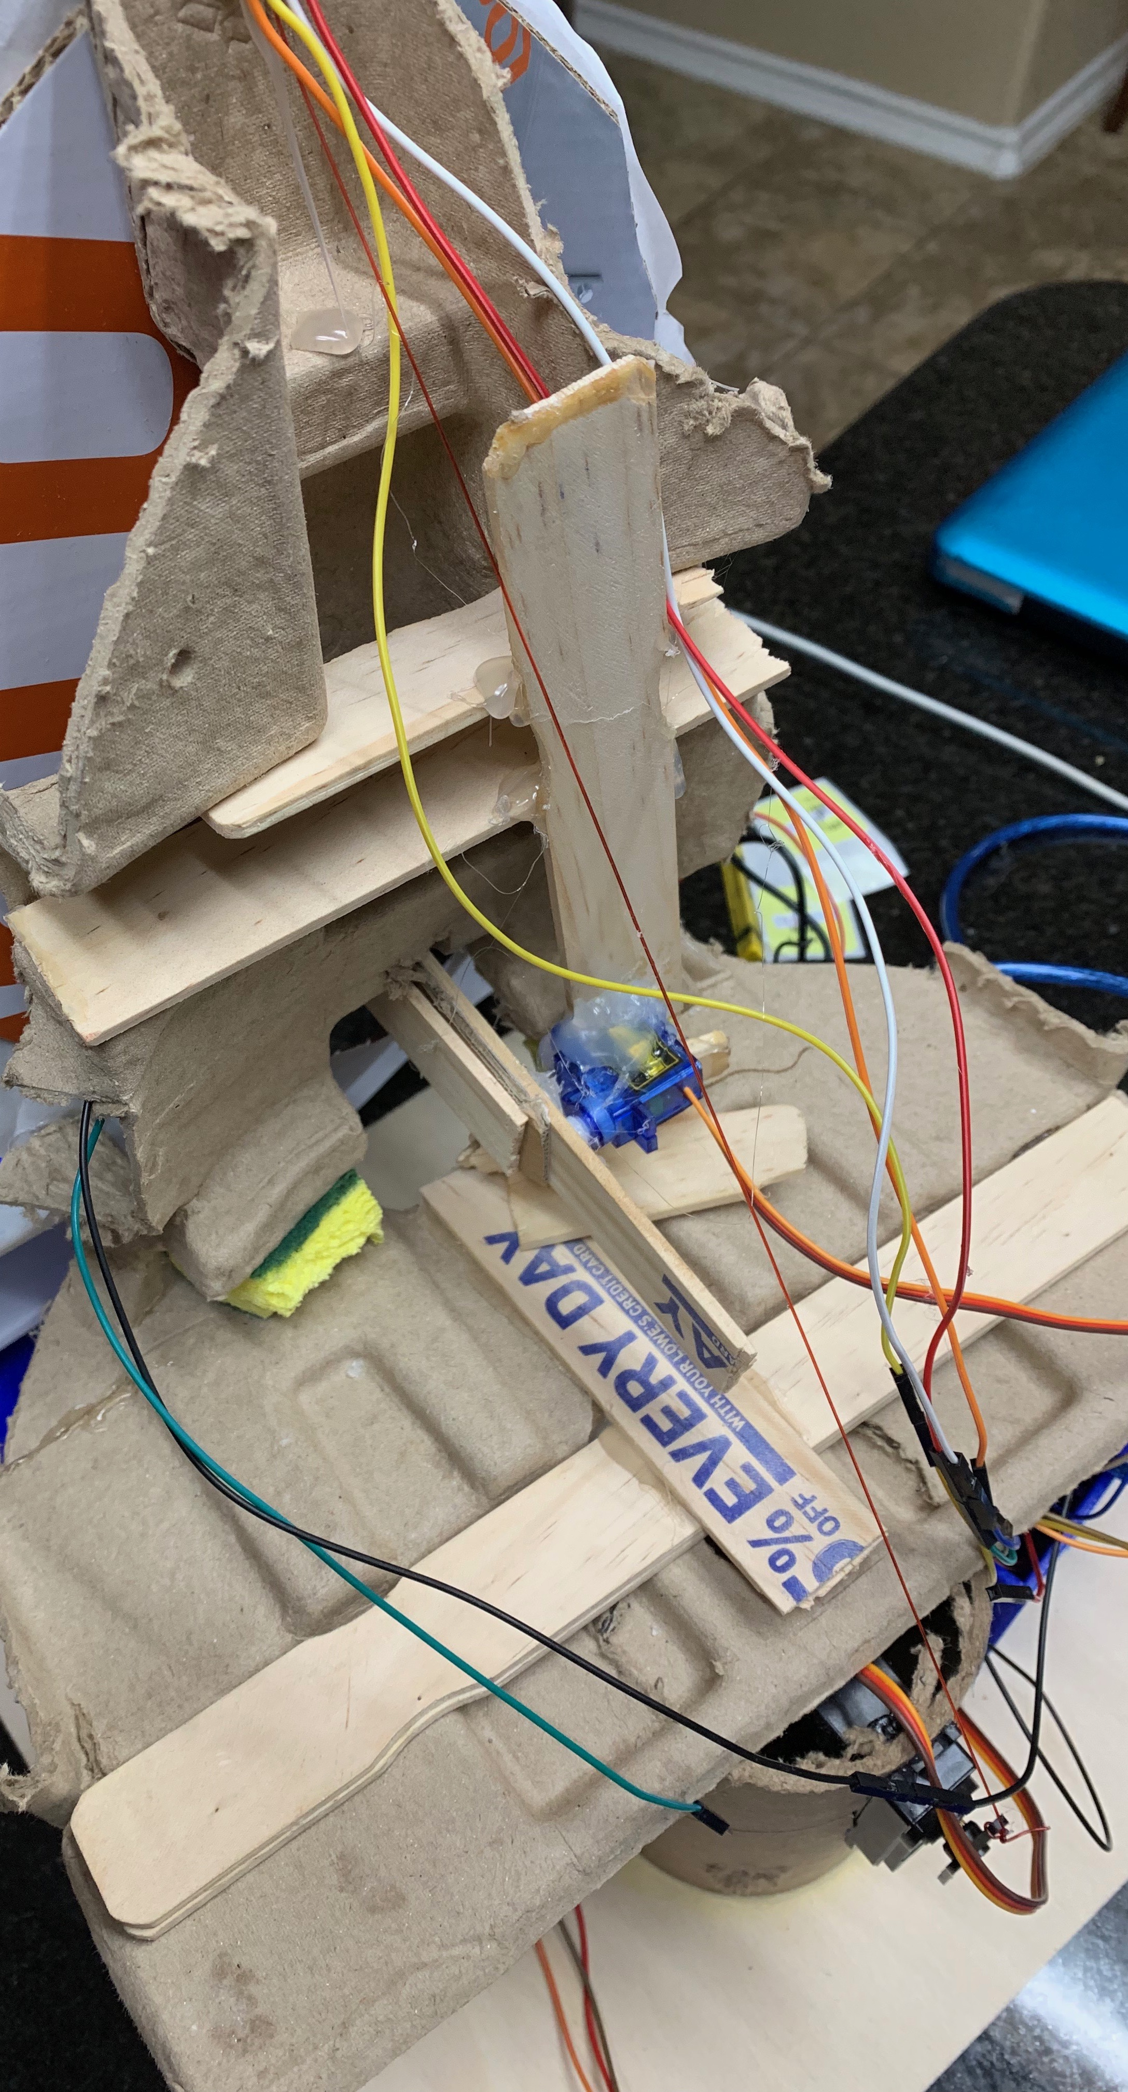

*Figure 5: Cardboard Structure with Wooden Supports*

After we selected the material for the face structure, a material for the neck was selected. Cardboard was actually utilized for this as well. Figure 6 below shows the cardboard that was utilized as the support material for the neck. Initially the team did not think cardboard would be strong enough for the neck since it must support the entire face, however the team found a cardboard cylinder that is quarter of an inch thick providing enough support to serve as the neck.

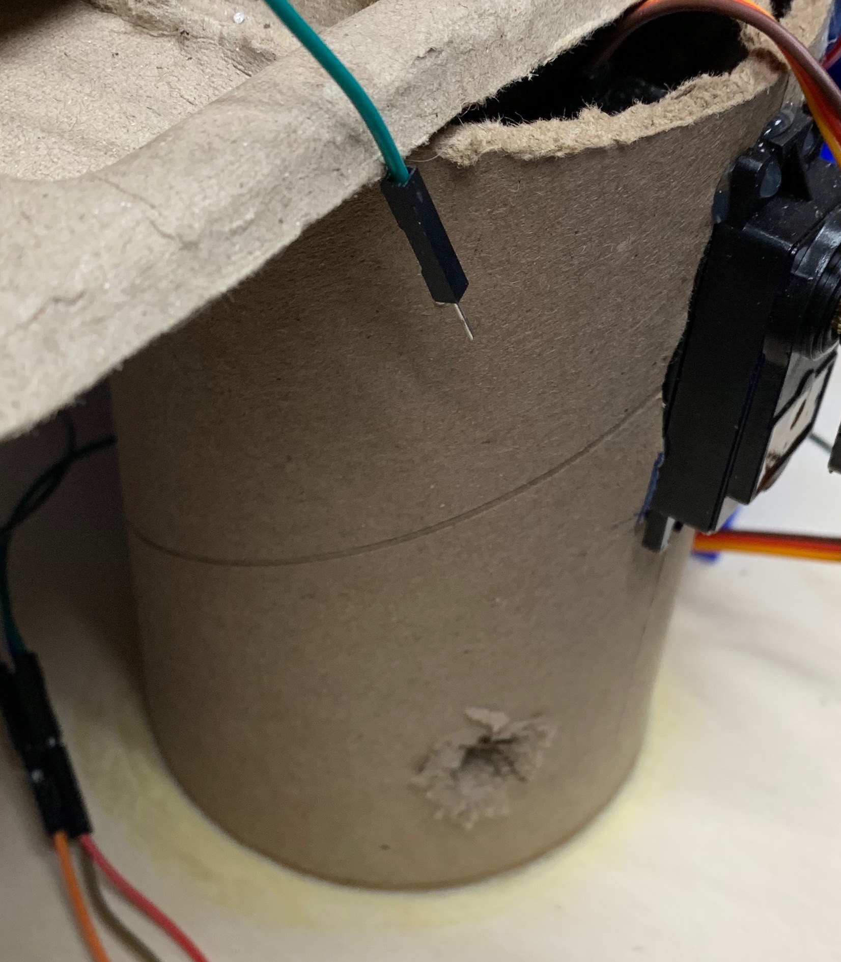

*Figure 6: Neck Support (Cardboard Tube)*

**Section 4: Joints and motors**

In order to achieve the specifications, set by the professor, the face must have at least two movements, which also means that it must have at least two joints. For each movement a joint is typically required. The first joint that was created was for the head tilt movement. An image of this joint is shown below in figure 7. The joint was created utilizing a bend that already existed in the geometry of the cardboard. The mating of the neck and face was created using gorilla glue. Gorilla glue was used for this joint because it was identified by the team as a critical point in terms of stress, so it needed a strong connection.

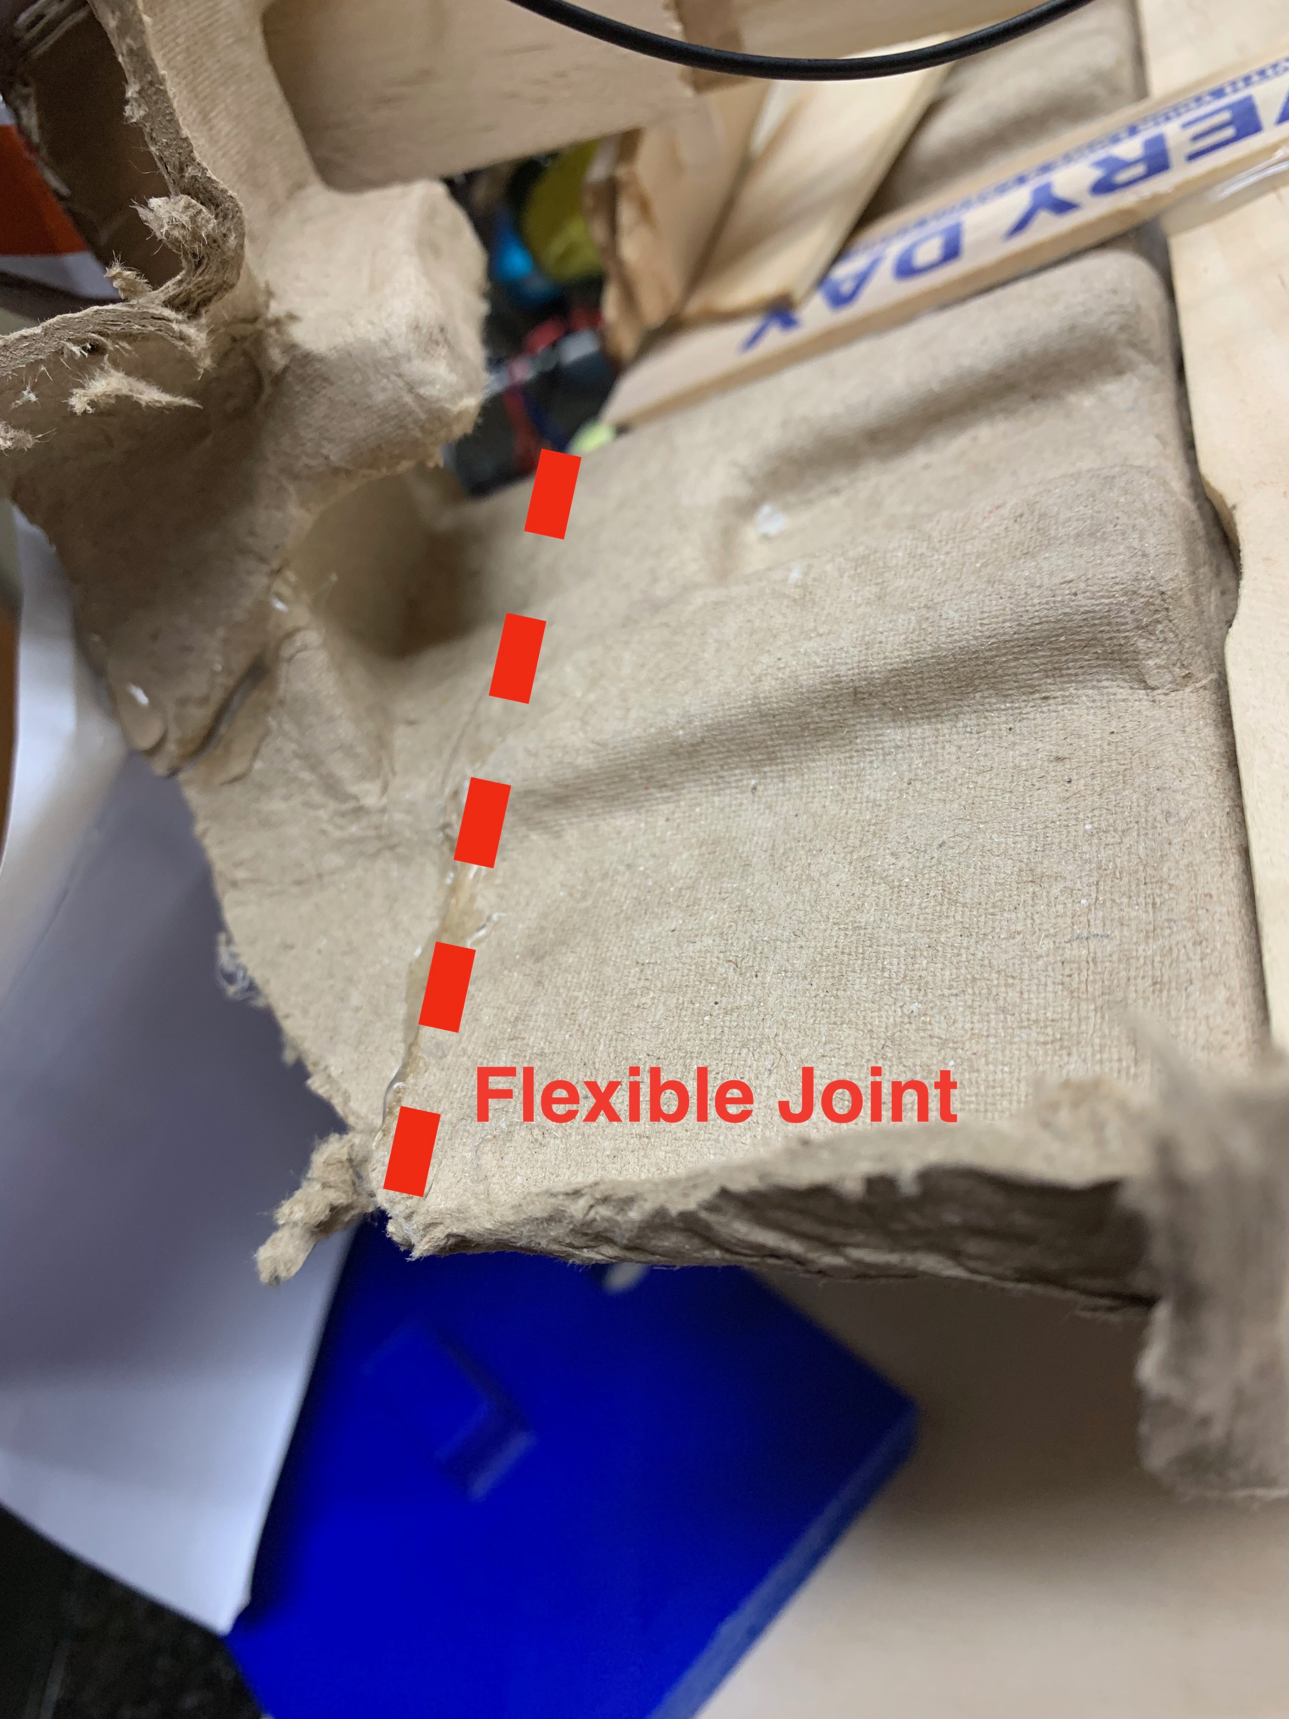

*Figure 7: Cardboard Flexible Joint*

The servo motor used for the next was a SunFounder Metal Gear Digital RC Servo Motor. A servo motor was selected for this movement because it allows for easy adjustments of motion and is a closed loop system that provides feedback. This motor was selected because of its high torque capabilities at 12.8 kgcm. The high torque was needed singe the purpose of this motor is to tilt the entire face assembly. An image of the motor used to tilt the head can be seen below in figure 8.

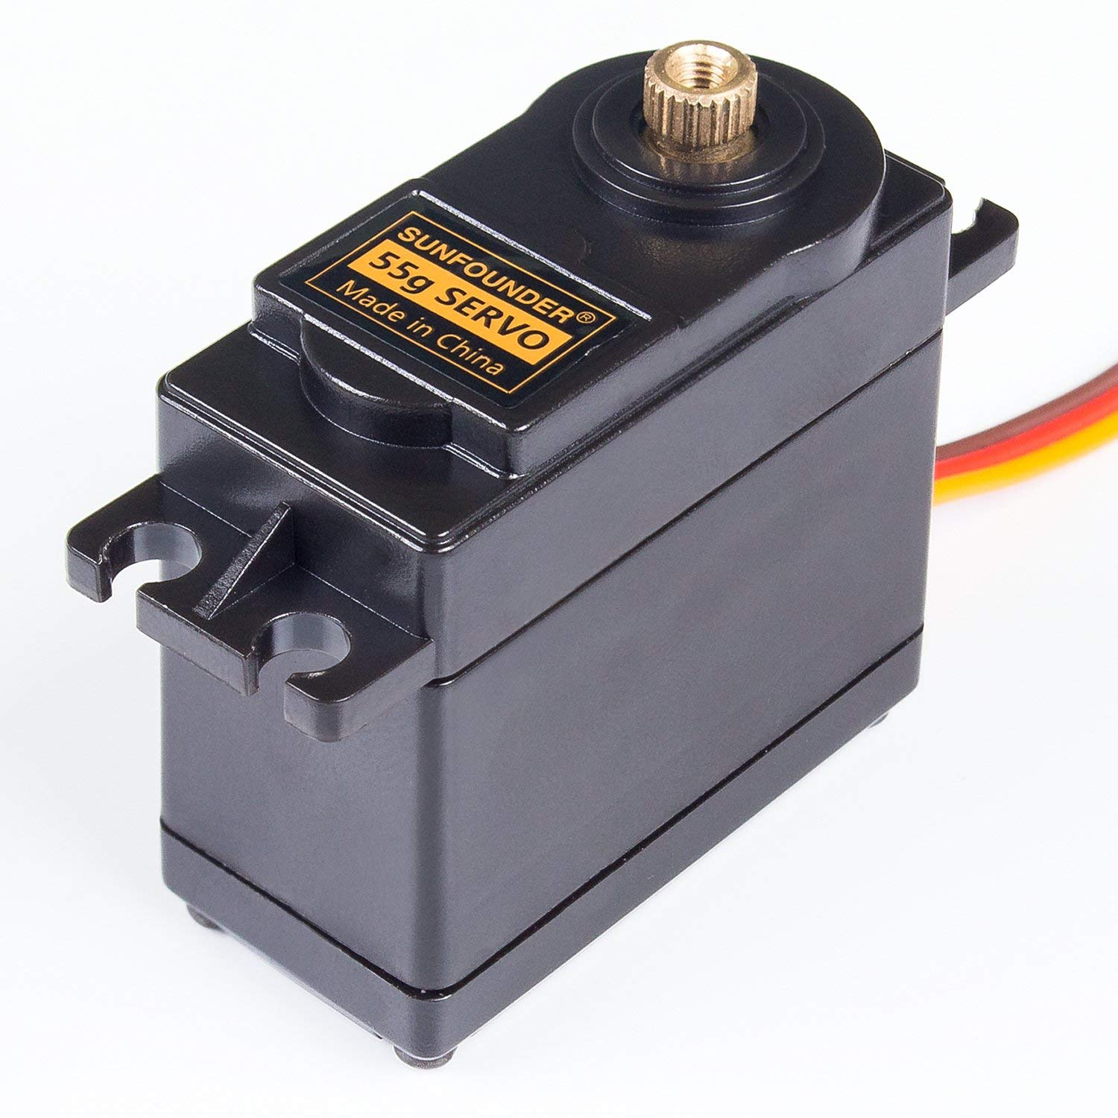

*Figure 8: SunFounder Metal Gear Digital RC Servo Motor*

The next joint that was created was for the movement of the mount. This was a much more difficult joint to create compared to the joint created for the neck. This joint was more difficult because the mouth mush moves linearly not circularly. The team achieved the desired motion by adding a lever to the back of the month. The lever was made out of a wooden paint stirring stick and was hot glued to the month. Figure 9 below shows an image of the lever for the movement of the mouth.

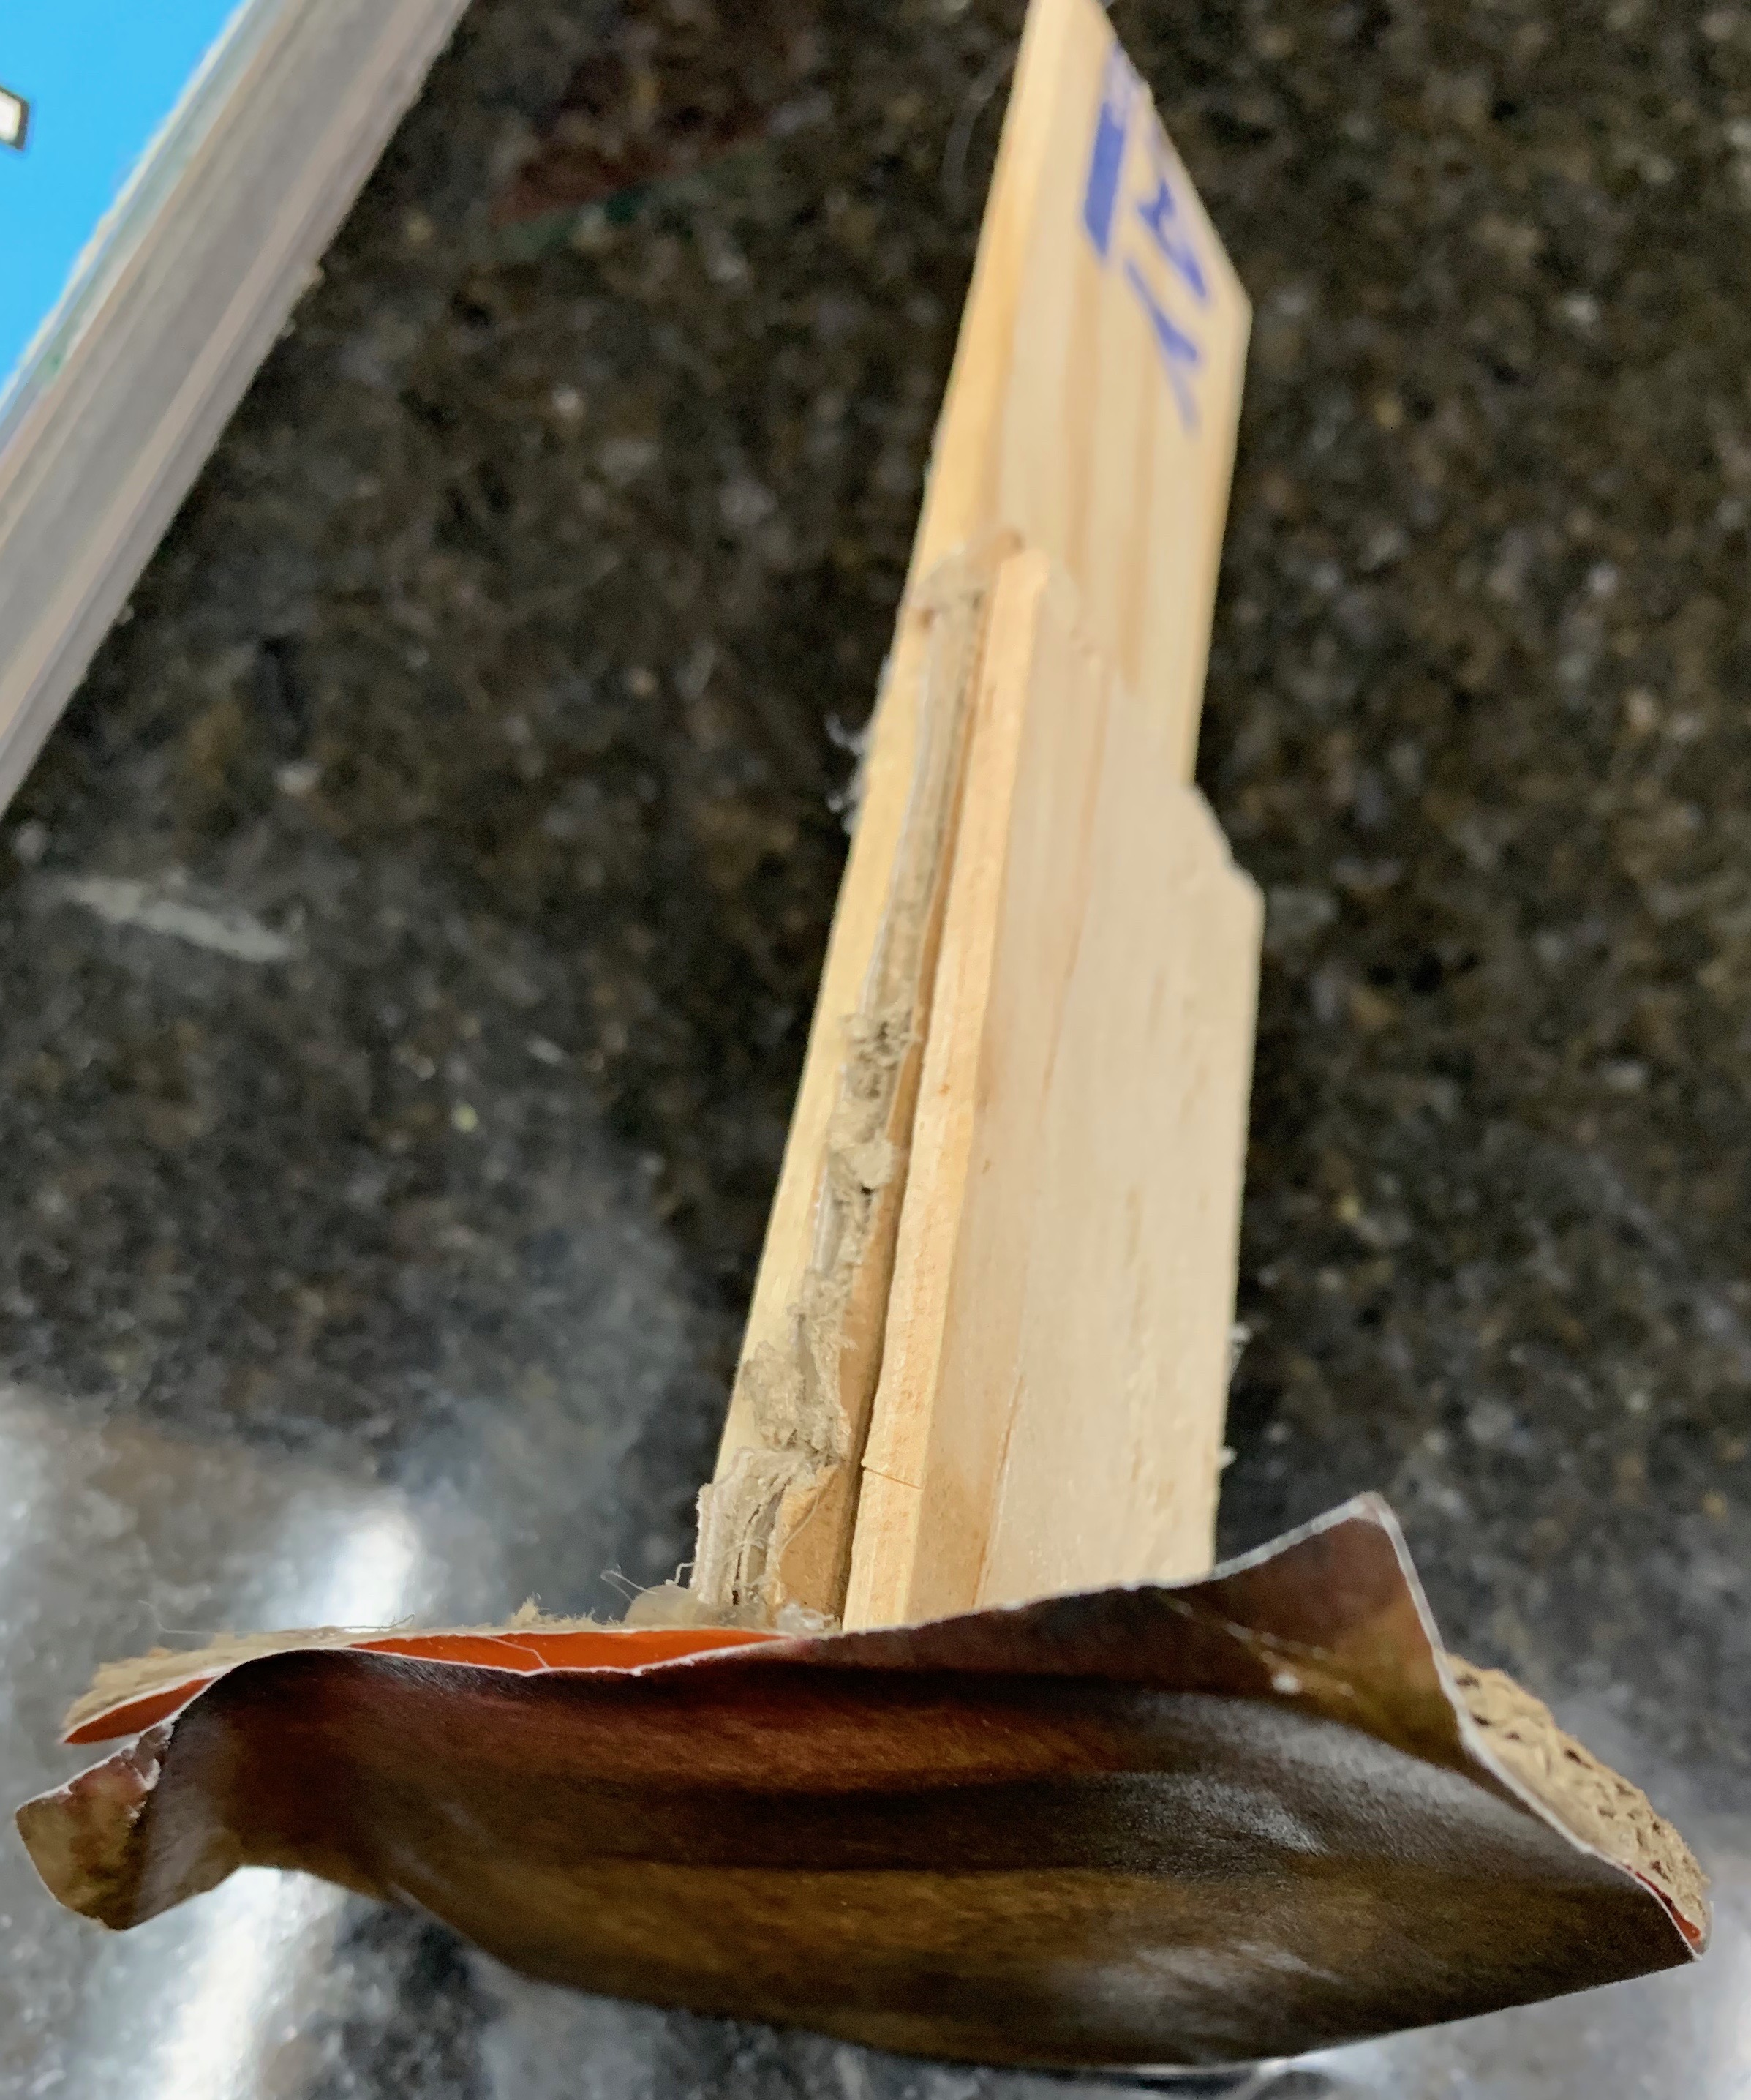

*Figure 9: Mouth Movement Lever*

After this wooden lever was installed the next step was to install a mount for the servo motor. In order to install a mount for the motor, a support beam was installed behind the face. The support beam is also made out of wood and can been seen below in figure 10.

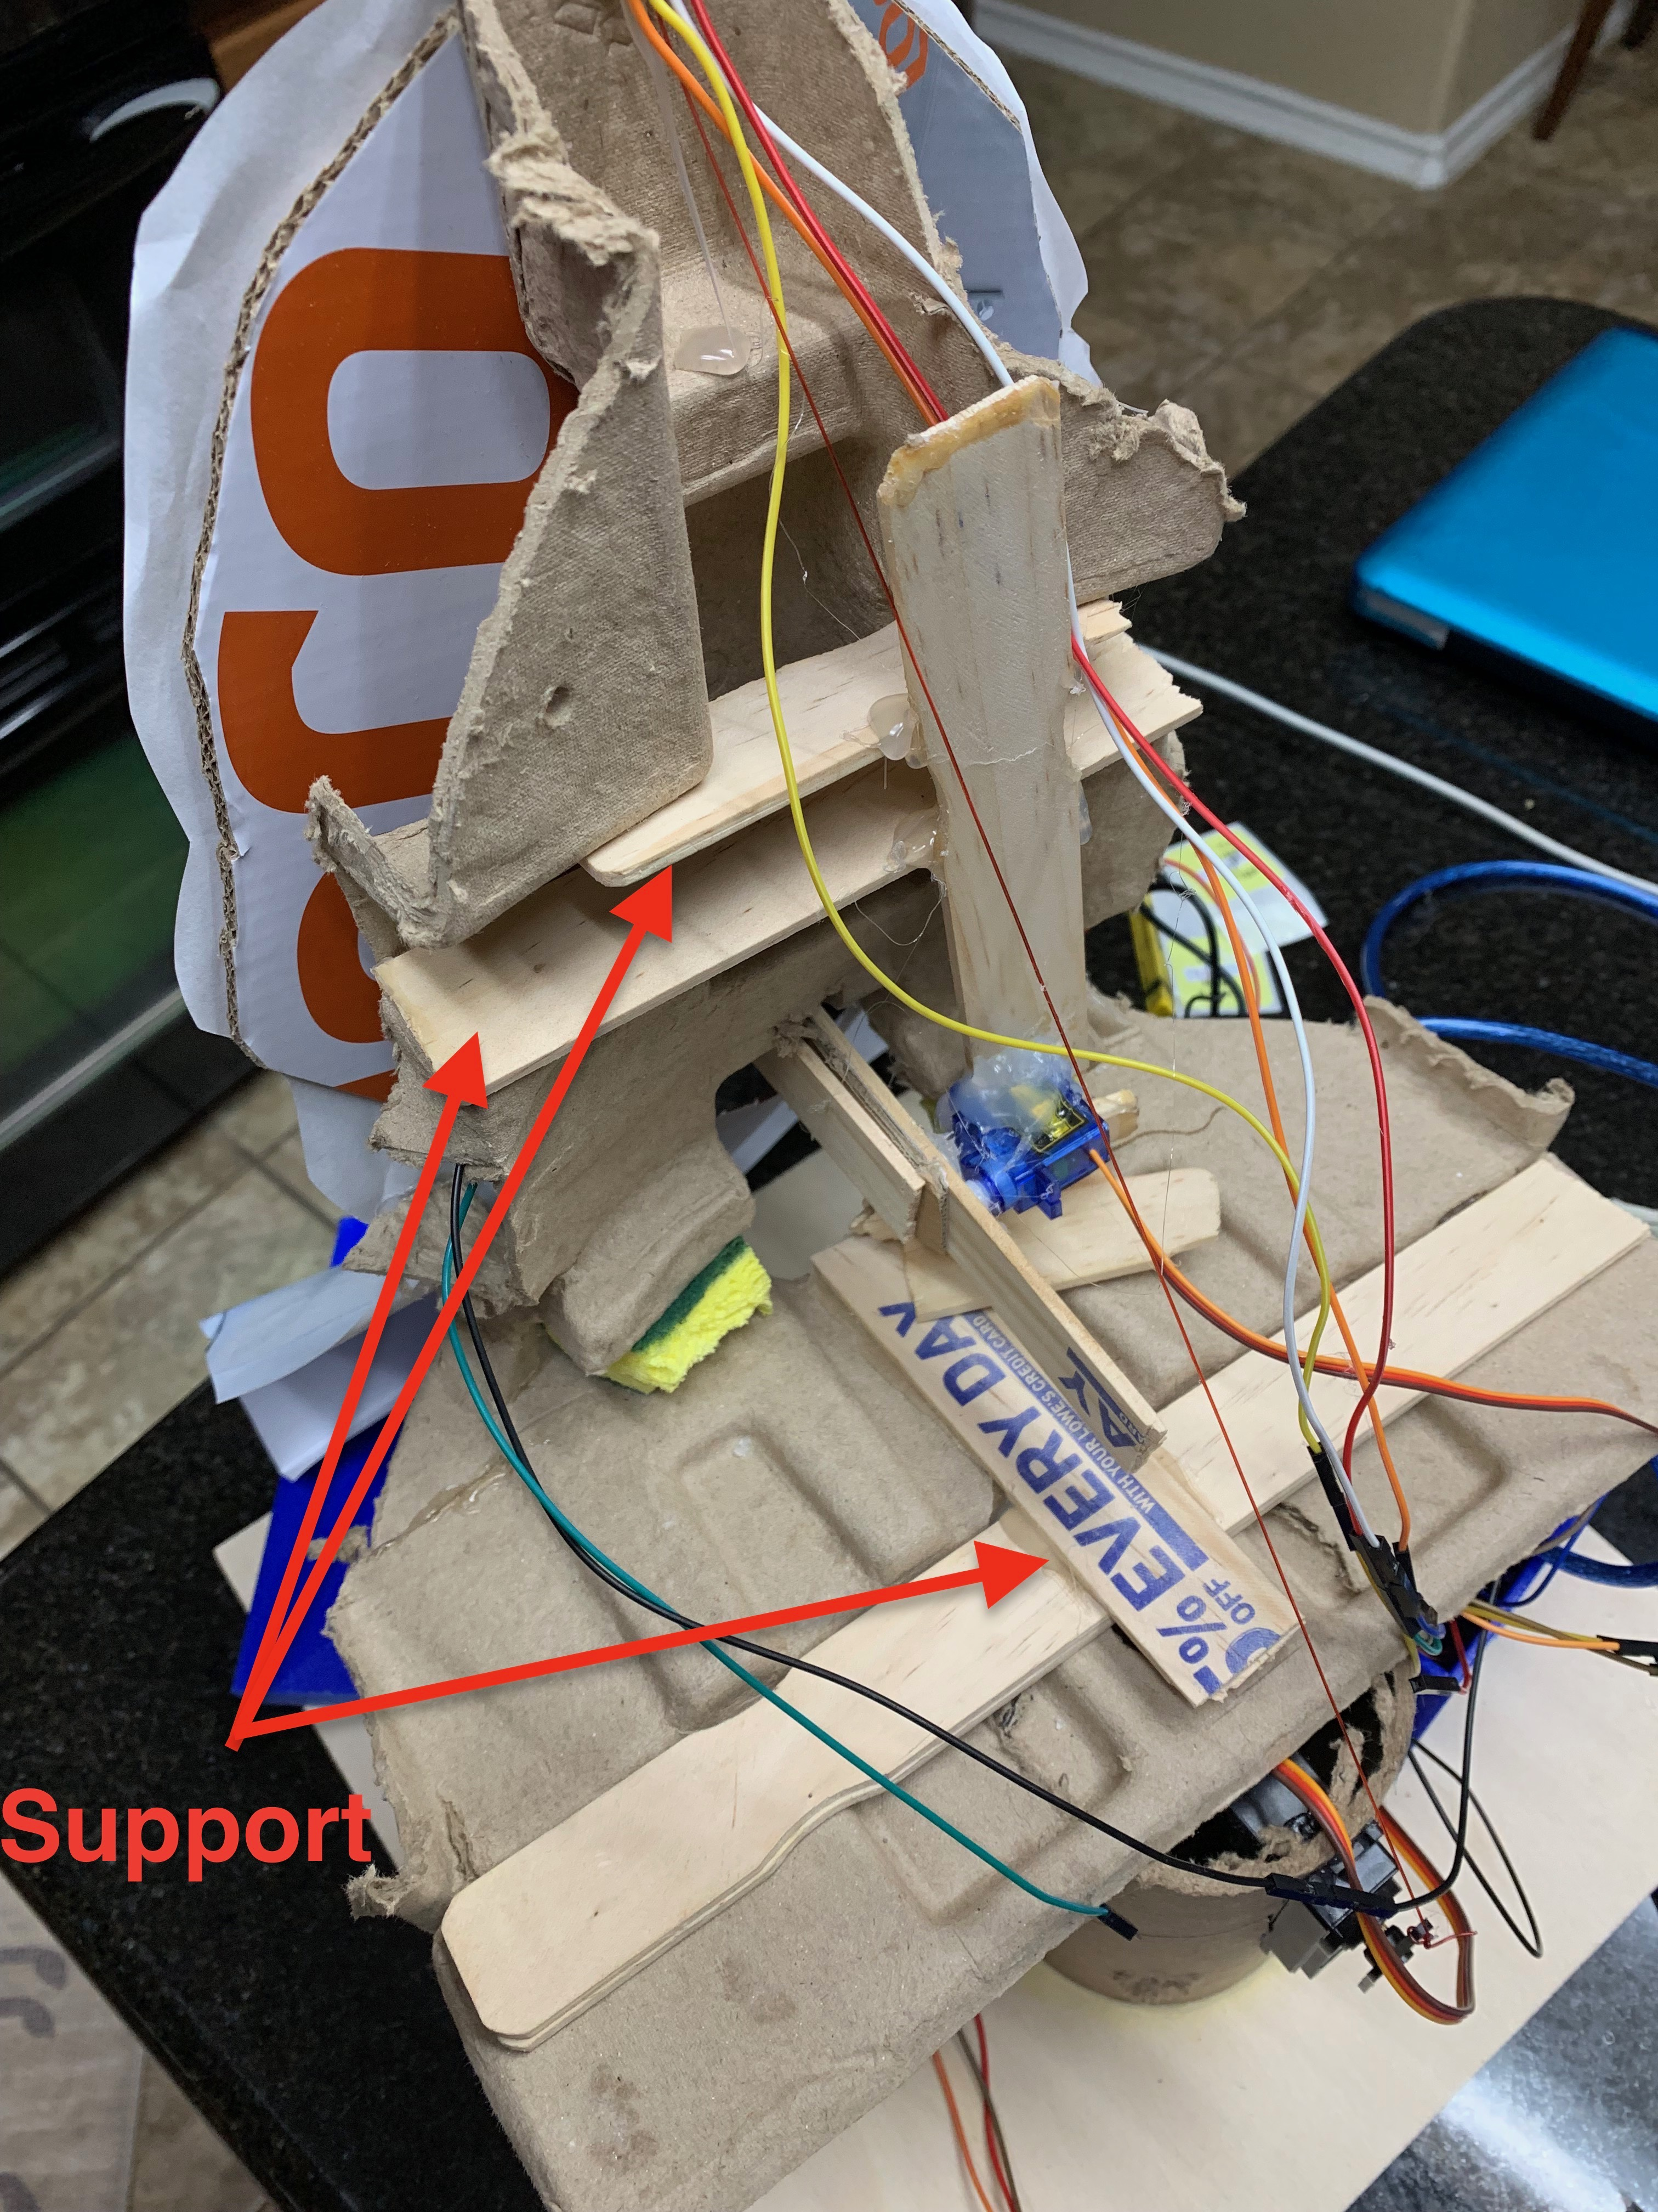

*Figure 10: Support Beams*

Once the support beam was installed now the mount for the mouth motor was installed. The motor mount was also a wood stirring stick and was mounted perpendicular to the support beam shown above in figure and was installed using hot glue. Next, the servo motor was glued to the wooden mount and the wood lever, allowing for proper motion of the month. The completed servo assembly for the can be seen below in figure 11.

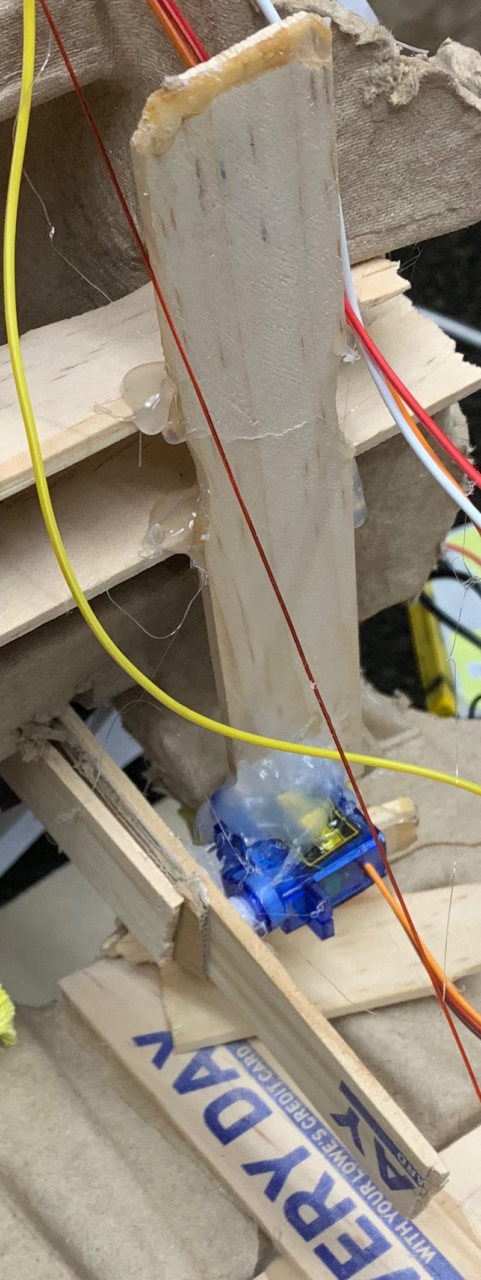

*Figure 11: Complete Assembly for Mouth*

The servo used for he mouths movement was a MakerDoIt Micro Arduino Servo Motor SG90. A servo motor was selected for this movement because it allows for easy adjustments of motion and is a closed loop system that provides feedback. This servo was used because the team already had this motor. The servo motor used for the mouth movement can be seen below in figure 12.

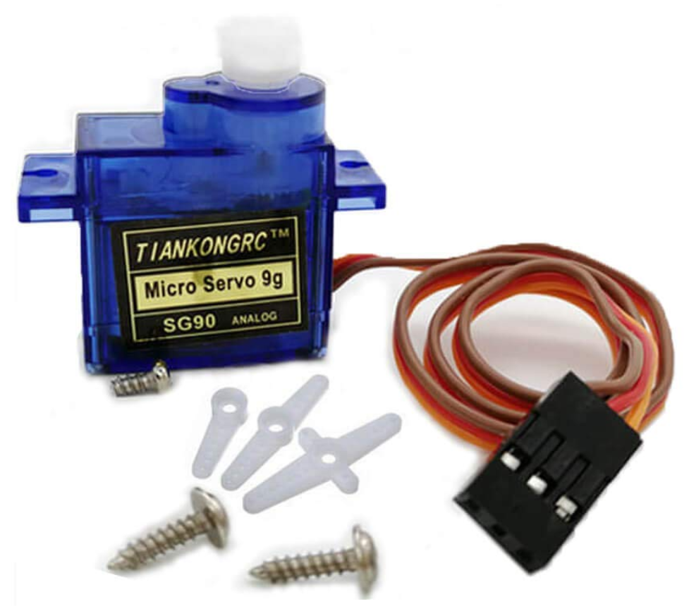

*Figure 12: MakerDoIt Micro Arduino Servo Motor SG90*

**Section 5: Sensors**

Sensors used on an animatronic face provide interaction between the face the audience. Three different sensors were used for this face. The first sensor that was used was a keyestudio pyroelectric infrared Motion Sensor. A PIR sensor is designed to detect warm objects, meaning objects such animals or people can trigger this sensor. The sensor detects IR because the lens is made out of a special material that is sensitive to IR [7]. The PIR sensor has two different zones that can been seen below in figure 14. The PIR is off when both zones detect the same amount of IR, however, according to Arduino, “When a warm body like a human or animal passes by, it first intercepts one half of the PIR sensor, which causes a*positive differential* change between the two halves. When the warm body leaves the sensing area, the reverse happens, whereby the sensor generates a negative differential change. These change pulses are what is detected” [7]. The PIR sensor was wired to trigger the mouth movements. This means that if a piece of paper is in front of the PIR sensor then animatronic mouth will not move. This sensor was selected for the mouth because the team did not want the face talking if nobody was actually standing in front to listen. An image of the PIR used for this project is shown below in figure 13.

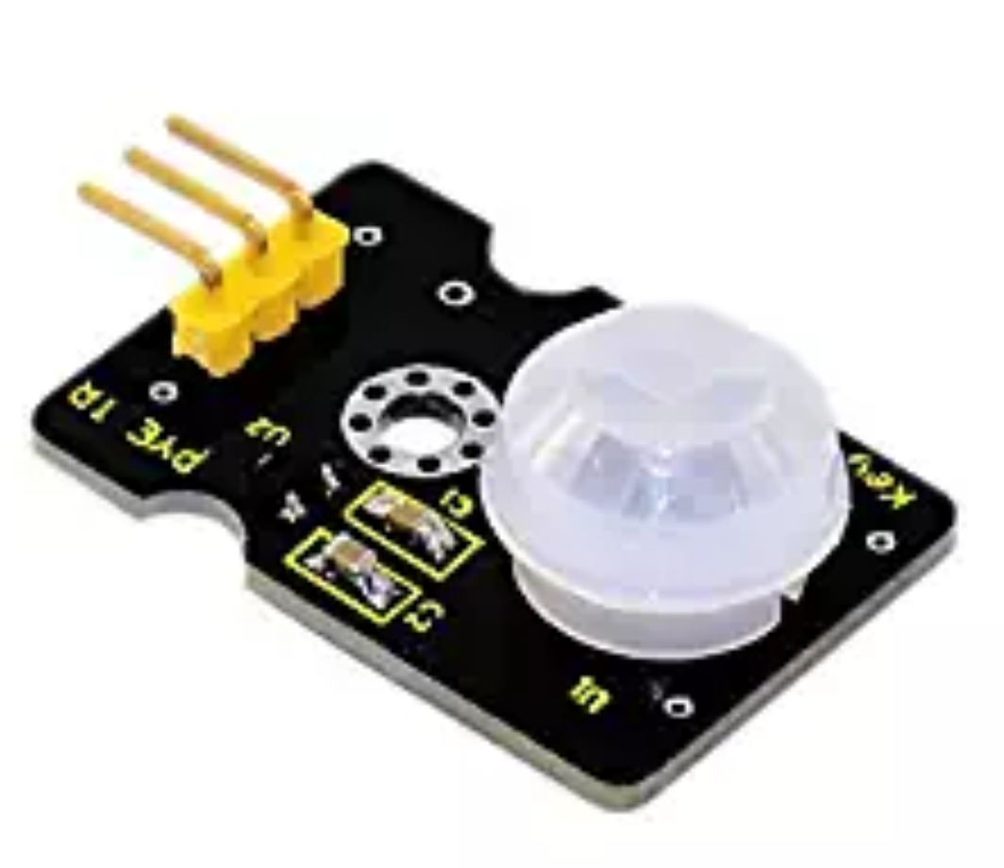

*Figure 13: PIR Sensor*

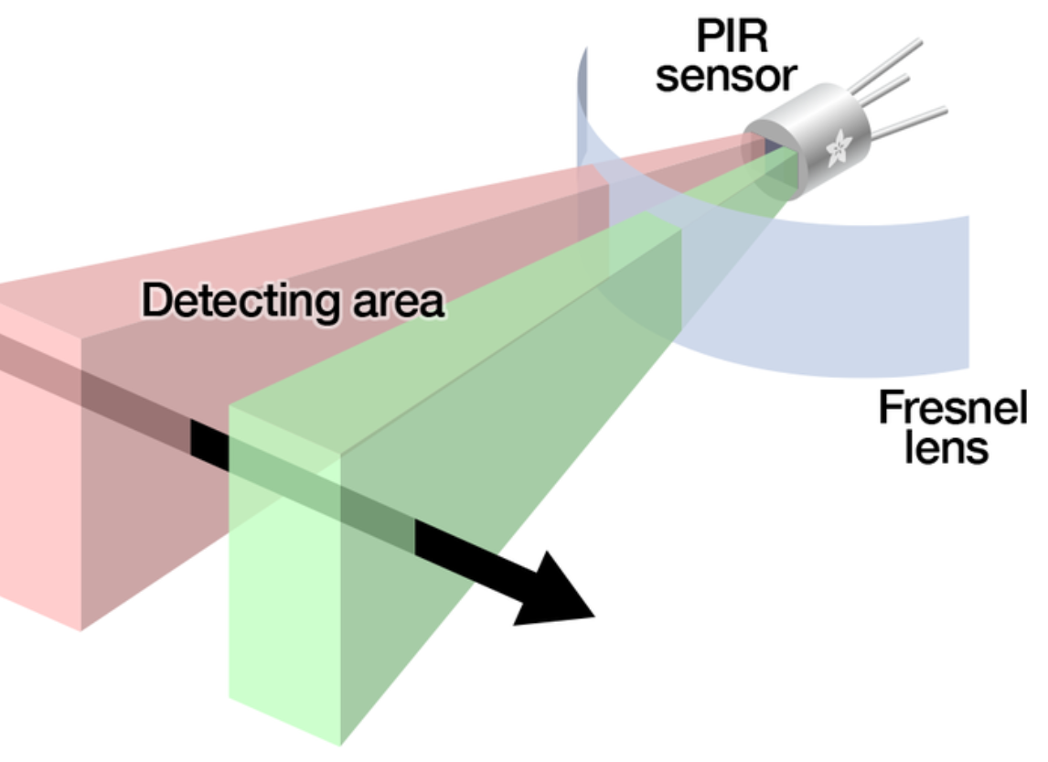

*Figure 14: PIR Zones*

The second sensor that was used was a HC-SR04 Ultrasonic Sensor Distance Module. According to Omron Industrial Automation a proximity sensor converts information on the movement or presence of an object into an electrical signal [8]. The proximity sensor was used to trigger the red LED lights that resemble eyes on the animatronic face. The sensor sends a signal and calculated distance based on how long it takes the signal to return to the sensor. That means this sensor is ideal for triggering the LED’s based on an object at a certain distance. An image of the proximity sensor used for this project is shown below in figure 15.

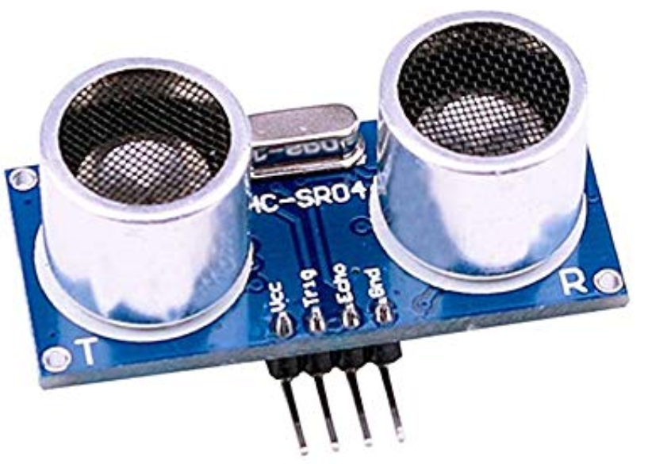

*Figure 15: HC-SR04 Ultra-Sonic Sensor*

The third sensor used to complete the animatronic face was a Heltec Automation HTTM-SCB Capacitive Touch Sensor. The sensor operates between 2.7-6 volts with an output of 500 mA and has zero mechanical parts. This sensor was used to trigger the Arduino that tilts the head. An image of the touch sensor used during this project can be seen below in figure 16.

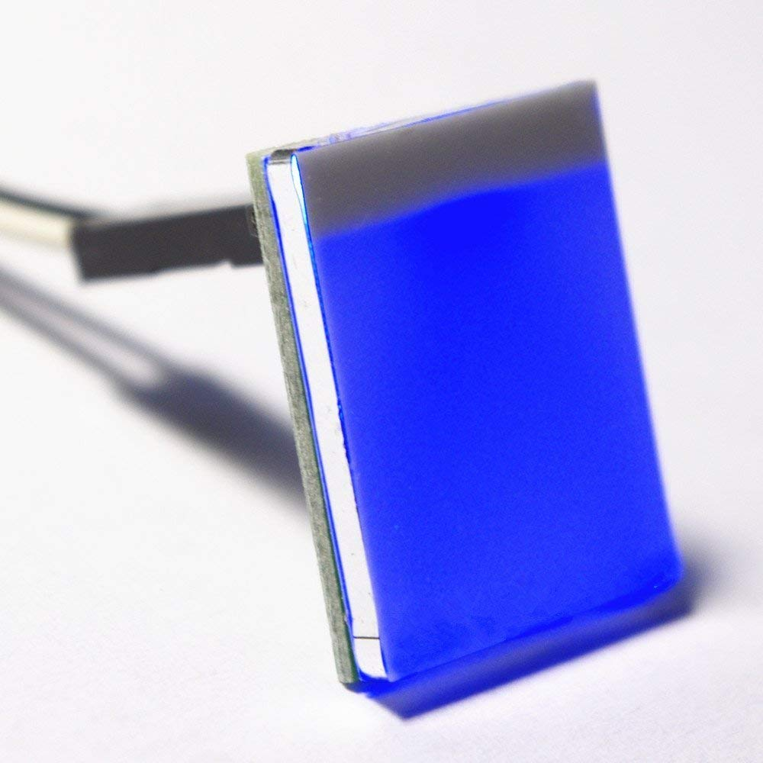

*Figure 16: Heltec Automation HTTM-SCB Capacitive Touch Sensor*

**Section 6: Programming for interaction**

Programing logic for the **PIR Sensor Operating a Servo** motor through an Arduino is done in the following steps for writing a code that sweeps the servo from 0 to 105 degrees.

1. A servo object must be created.
2. Set the variable to store the servo position.
3. Set the amount of time to give the sensor to calibrate.
4. Set the time when the sensor outputs a low impulse.
5. Assign the amount of milliseconds the sensor has to be low before assuming all motion has stopped.
6. Assign digital pin connected to the PIR’s Output
7. Assign digital pin connected to the PIR’s 5V
8. Assign digital pin to attach servo motor
9. Define time for the sensor to calibrate
10. Define that the system wait until the PIR’s output is low before ending setup
11. Define if the PIR output is HIGH to turn servo from 0 to 105 degrees in steps of 3 degrees per 5 milliseconds
12. Define from 105 to 0 degrees in steps of 3 degrees per 5 milliseconds
13. Define your delays which can speed up the servo by decreasing the time in delay or vise versa
14. Identify that the output is low before further output is made
15. Save the time of the transition from High to Low (make sure this is only done at the start of a low phase)
16. Define that if the sensor is low for more than the given pause (assume the motion has stopped)
17. Define that the block of code s only excuted again after a new motion sequence has been detected

Programing logic for the **Ultrasonic Sensor Operating LED Lights** through an Arduino is done in the following steps.

1. Define the trigger Pin
2. Define the Echo Pin
3. Define the LED Pin
4. Define each Pin Mode
5. Set the High and Low value with delays for the trigger pin
6. Define the distance for the sensor to read

Programing logic for the **Touch Sensor Operating Servo Motor** through an Arduino is done in the following steps.

1. Include the servo Library
2. Create an instance of the servo object to control a servo
3. Define control pin for servo motor
4. Initialize serial communications
5. Attaches the servo on pin 2 to the servo object
6. Read the analog input and define the analog input for the touch sensor
7. Print it
8. If the sensor’s range is less than 0 to 1023 modify the map function to use the values you discovered
9. Move the servo using the angle from the sensor

Programing logic for the **SD card shield** through an Arduino is done in the following steps.

1. Include SD.h to read SD card
2. Include TMRpcm.h to play audio
3. Include SPI.h library for SD card
4. Import audio to SD card
5. Convert audio files to wav using online WAV converter
6. Format the SD card
7. Hook up module as follows

|  |  |
| --- | --- |
| **Arduino** | **SD card module** |
| +5V | Vcc |
| Gnd | Gnd |
| Pin 12 | MISO (Master In Slave out) |
| Pin 11 | MOSI (Master Out Slave In) |
| Pin 13 | SCK (Synchronous Clock) |
| Pin 4 | CS (Chip Select) |

1. Add Zip file into Arduino
2. Attach speakers
3. Play selected file

The Youtube video of this creation can be seen at <https://www.youtube.com/watch?v=o5JcpO4JS6U>.

**Section 7: Lessons learnt and suggestions**

1. Regarding the audio portion, the first attempt to incorporate audio to the Arduino resulted in failure.
2. The process used a binary to header conversion to project the sound out of the speaker which did not work due to error reading the code.
3. Lesson learned: incorporating audio is not as easy as converting an audio file and incorporating into a program.
4. Next attempt used a WTV 020 MP3 sound module to upload a MP3 file to the board.
5. Again, the program could not read the code due to improper labeling of pins on the module used which resulted in error.
6. Lesson learned: need proper schematics to hook up card module.
7. Third attempt used a SenMod microSD card adaptor reader module used to plug in a 1 gigabyte micro SD card.
8. The third process worked, and sound was able to be projected out of the Arduino.
9. Lesson learned: always have different methods ready in case of malfunctions or unsuccessful attempts.

**Section 8: Personnel and bill of materials**

**(a) Personnel**

|  |  |  |
| --- | --- | --- |
| Task | Main Personnel | Secondary personnel |
| Structure/Chassis Design | Ryan | Sean |
| Joints/Motor Interfacing | Sean | Ryan |
| Sensor Interfacing | Ryan | Sean |
| Programing Motion | Sean | Ryan |
| Programing Audio | Johnathan |  |
| Report | Ryan/Sean | Johnathan |

*Table 1: Personnel Task List*

**(b) Bill of materials**



*Table 2: Bill of Materials*

**References**

[1] Hirth, J., Schmitz, N., & Berns, K. (n.d.). Emotional Architecture for the Humanoid Robot

Head ROMAN. Retrieved October 19, 2018, from <http://mindtrans.narod.ru/pdfs/ROMAN.pdf>

[2] “Animatronic Mouths.” *PyroElectro.com*,

[www.pyroelectro.com/tutorials/animatronic_mouths/parts.html](http://www.pyroelectro.com/tutorials/animatronic_mouths/parts.html)

[3] “What is PIC Microcontrollers? - Definition from WhatIs.com.” *WhatIs.com*,

whatis.techtarget.com/definition/PIC-microcontrollers.

[4] ENGINEERING.com. “Servo Motors.” *Engineering.com*,

[www.engineering.com/ProductShowcase/ServoMotors.aspx](http://www.engineering.com/ProductShowcase/ServoMotors.aspx).

[5] 141, K. (2011, February 12). *Instructables*. Retrieved from www.instructables.com: https://www.instructables.com/id/Talking-Animatronic-Robot-Head/

[6] *Brookshire Software LLC*. (n.d.). Retrieved from www.brookshire.com: https://www.brookshiresoftware.com/rapu3_overview.htm

[7]“PIR Motion Sensor.” *Memory Architectures | Memories of an Arduino | Adafruit Learning System*, learn.adafruit.com/pir-passive-infrared-proximity-motion-sensor/how-pirs-work.

[8] [Check paper for grammar errors](https://www.citationmachine.net/grammar-and-plagiarism/) “Proximity Sensors.” *OMRON*, www.ia.omron.com/support/guide/41/introduction.html.

**Appendix A Code:**

**PIR Operating a Servo Motor Code**

#include <Servo.h>

Servo myservo; //creates a servo object

//a maximum of eight servo objects can be created

int pos = 0; //variable to store servo position

//amount of time we give the sensor to calibrate(10-60 secs according to the datasheet)

int calibrationTime = 10;

//the time when the sensor outputs a low impulse

long unsigned int lowIn;

//the amount of milliseconds the sensor has to be low

//before we assume all motion has stopped

long unsigned int pause = 50;

boolean lockLow = true;

boolean takeLowTime;

int pirPin = 12; //digital pin connected to the PIR's output

int pirPos = 13; //connects to the PIR's 5V pin

void setup(){

myservo.attach(4); //attaches servo to pin 4

Serial.begin(9600); //begins serial communication

pinMode(pirPin, INPUT);

pinMode(pirPos, OUTPUT);

digitalWrite(pirPos, HIGH);

//give the sensor time to calibrate

Serial.println("calibrating sensor ");

for(int i = 0; i < calibrationTime; i++){

Serial.print(calibrationTime - i);

Serial.print("-");

delay(100);

}

Serial.println();

Serial.println("done");

//while making this Instructable, I had some issues with the PIR's output

//going HIGH immediately after calibrating

//this waits until the PIR's output is low before ending setup

while (digitalRead(pirPin) == HIGH) {

delay(500);

Serial.print(".");

}

Serial.print("SENSOR ACTIVE");

}

void loop(){

if(digitalRead(pirPin) == HIGH){ //if the PIR output is HIGH, turn servo

/*turns servo from 0 to 105 degrees and back

it does this by increasing the variable "pos" by 3 every 5 milliseconds until it hits 105

and setting the servo's position in degrees to "pos" every 5 milliseconds

it then does it in reverse to have it go back

to learn more about this, google "for loops"

to change the amount of degrees the servo turns, change the number 105 to the number of degrees you want it to turn

**/

for(pos = 0; pos < 105; pos += 3) //goes from 0 to 105 degrees

{ //in steps of three degree

myservo.write(pos); //tells servo to go to position in variable "pos"

delay(5); //waits for the servo to reach the position

}

for(pos = 105; pos>=1; pos-=3) //goes from 105 to 0 degrees

{

myservo.write(pos); //to make the servo go faster, decrease the time in delays for

delay(5); //to make it go slower, increase the number.

}

if(lockLow){

//makes sure we wait for a transition to LOW before further output is made

lockLow = false;

Serial.println("---");

Serial.print("motion detected at ");

Serial.print(millis()/100);

Serial.println(" sec");

delay(50);

}

takeLowTime = true;

}

if(digitalRead(pirPin) == LOW){

if(takeLowTime){

lowIn = millis(); //save the time of the transition from HIGH to LOW

takeLowTime = false; //make sure this is only done at the start of a LOW phase

}

//if the sensor is low for more than the given pause,

//we can assume the motion has stopped

if(!lockLow && millis() - lowIn > pause){

//makes sure this block of code is only executed again after

//a new motion sequence has been detected

lockLow = true;

Serial.print("motion ended at "); //output

Serial.print((millis() - pause)/100);

Serial.println(" sec");

delay(50);

}

}

**Ultrasonic Sensor Operating LED Lights Code**

#define trigPin 13

#define echoPin 12

#define led 11

void setup()

{ Serial.begin (9600);

pinMode(trigPin, OUTPUT);

pinMode(echoPin, INPUT);

pinMode(led, OUTPUT);

}

void loop()

{ long duration, distance;

digitalWrite(trigPin, LOW);

delayMicroseconds(2);

digitalWrite(trigPin, HIGH);

delayMicroseconds(10);

digitalWrite(trigPin, LOW);

duration = pulseIn(echoPin, HIGH);

distance = (duration/2) / 29.1;

if (distance < 100)

{ digitalWrite(led,HIGH);

}

else {

digitalWrite(led,LOW);

}

Serial.print(distance);

Serial.println(" cm");

delay(100);

}

**Touch Sensor Operating Servo Motor Code**

include <Servo.h> // include the servo library

Servo servoMotor; // creates an instance of the servo object to control a servo

int servoPin = 3; // Control pin for servo motor

void setup() {

Serial.begin(9600); // initialize serial communications

servoMotor.attach(servoPin); // attaches the servo on pin 2 to the servo object

}

void loop()

{

int analogValue = analogRead(A0); // read the analog input

Serial.println(analogValue); // print it

// if your sensor's range is less than 0 to 1023, you'll need to

// modify the map() function to use the values you discovered:

int servoAngle = map(analogValue, 0, 523, 0, 179);

// move the servo using the angle from the sensor:

servoMotor.write(servoAngle);

}

**Push button audio activation code**

#include "SD.h" //Lib to read SD card

#include "TMRpcm.h" //Lib to play auido

#include "SPI.h" //SPI lib for SD card

#define SD_ChipSelectPin 4 //Chip select is pin number 4

TMRpcm music; //Lib object is named "music"

int song_number=0;

void setup(){

music.speakerPin = 9; //Auido out on pin 9

Serial.begin(9600); //Serial Com for debugging

if (!SD.begin(SD_ChipSelectPin)) {

Serial.println("SD fail");

return;

}

pinMode(2, INPUT_PULLUP); //Button 1 with internal pull up to chage track

music.setVolume(5); // 0 to 7. Set volume level

music.quality(1); // Set 1 for 2x oversampling Set 0 for normal

//music.volume(1); // 1(up) or 0(down) to control volume

//music.play("1",1); plays a file starting at 30 seconds into the track

}

void loop()

{

if (digitalRead(2)==LOW) //Button 1 Pressed

{

song_number++;

if (song_number==5)

{song_number=1;}

Serial.println("KEY PRESSED");

Serial.print("song_number=");

Serial.println(song_number);

if (song_number ==1)

{music.play("1.wav");} //Play song 1 from 10th second

}

}

**Appendix B Arduino Wiring**



*Figure 17: Ultra-Sonic Sensor with LED Wiring Diagram*

**

*Figure 18: Captive Touch Sensor with Servo Motor Wiring Diagram*

**

*Figure 19: PIR Sensor with Servo Wiring Diagram*